Prayer | Liturgy | Mass | Hymns | Vocabulary
*Children are able to make the sign of the cross  *Children are able to put their hands together when they pray  *Children are able to say the Our Father  *Children are able to say the morning prayer, lunch prayer and end of day prayer | *Children are able to gather together  *Children know that our special book is called the Bible  *Children enter prayer and worship with hands together. | *A priest celebrates Mass  *We sing hymns and pray together. | *Here I am Lord  *You have called us by our name  *Cauliflowers fluffy  *Our God is a great big God  *This little light of mine | God  Jesus  Mary  Gather  Pray  Celebrate  Priest  Hymns  Bible  Holy Spirit
Images
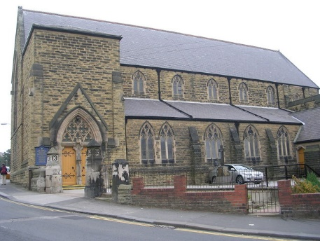
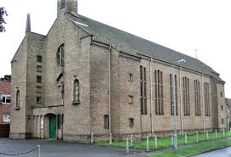
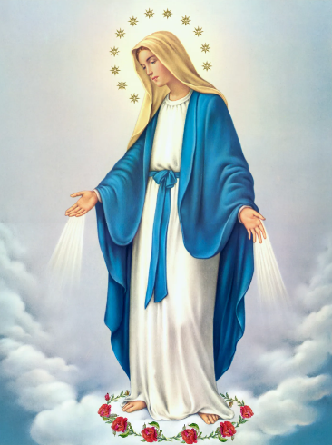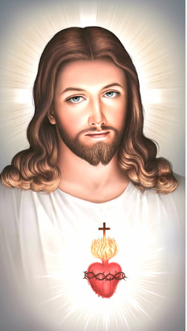

EYFS

Year 1 + 2
Prayer | Liturgy | Mass | Hymns | Vocabulary
*Hail Mary  *St Peter’s School Prayer  *Glory Be | *Children can explain the importance of gathering together  *Children recognize the symbolism of lighting a candle.  *Children know the correct colours for the liturgical season and when they are used.  Children can bless themselves with Holy water. | *People do special jobs in church  *Mass is the special meal that celebrates the Last Supper  *The Mass has four parts – gather, listen, give thanks, go out  *The parish family prepare to receive Holy Communion  *The parish go out and spread the Good News | *Creator God  *Shine Jesus Shine  *He’s got the whole world in his hands  *Do this in memory of me  *He is risen  *One Family  *Light the Advent Candle  *City on a Hill | Psalm  Gospel  Old Testament  New Testament  Litany  Family of God  Parish  Response  Baptism  Sacrament  Signs and symbols  Font  Chrism  Advent  Annunciation  Visitation  Altar  Ash Wednesday  Lent  Good Friday  Resurrection  Easter Sunday  Easter Candle  Alleluia  Holy Communion  Host  Chalice  Pentecost  Forgive  Sign of peace  Neighbour  Examination of Conscience
Images
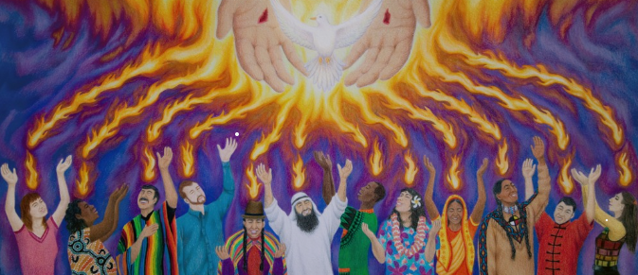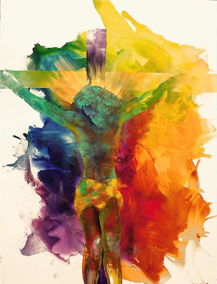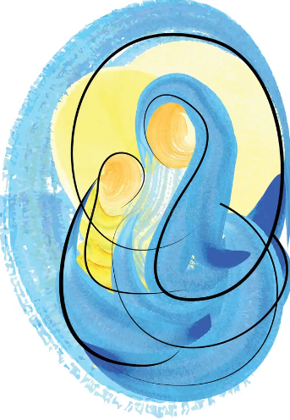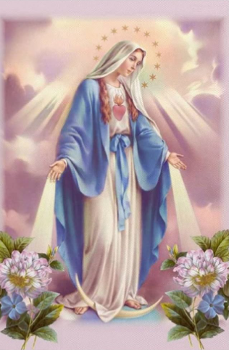

Year 3 + 4
Prayer | Liturgy | Mass | Hymns | Vocabulary
*Eternal Rest  *Sanctus  *St Cuthbert’s Trust Prayer | *Children know that there are Feast Days  *Children know that there is a Liturgical Calendar and when the Church year starts and ends  * Children know the importance of joining hands together and pointing towards heaven.  * Children to lead prayer and offer suggestions of ways to gather in prayer and why. | *The Penitential Act reminds the parish of the mystery of Christ’s love.  *The parish give glory to God in the Gloria  *The gifts are offered and the parish say the Creed  *The Eucharistic Prayer gives thanks for all God’s goodness  * The Christian family comes to the Lord’s table united in love of Jesus and one another. Communion with Jesus is celebrated in prayers and actions.  *The parish are sent out to live in love, friendship and communion with God and with one another. | *Yes Lord Believe  *Here I am to worship  *My Lighthouse  *Servant King  *Blessed be God  *Big family of God  *Resurrection Day  *Bless are you Lord  *God greatest gift  *Mary did you know | Love one another  Promises  Anoint  Called  Sacrament of Confirmation  Catechist  Bishop  Witness  Holy Trinity  Litany of Saints  Messiah  Joyful mysteries  Liturgical seasons and calendar  Ordinary time  Feast days  Our Lady  Eucharist  Penitential Act  Liturgy of the Word  Liturgy of the Eucharist  Creed  Eucharistic Prayer  Communion Rite  Lamb of God  Sign of Peace  Holy Week  Fasting  Alms giving  Sorrowful Mysteries  Rosary  Glorious Mysteries  Gifts of the Holy Spirit  Reconciliation  Confession  Sin  Penance  Contrition  Absolution  Pilgrimage
Images
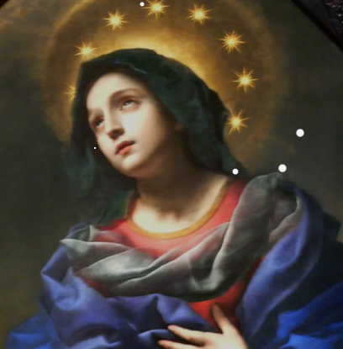
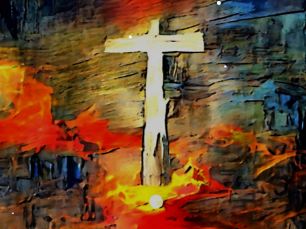
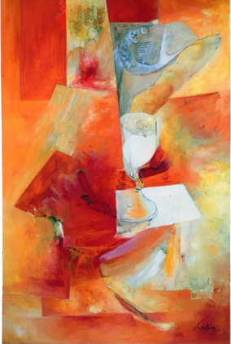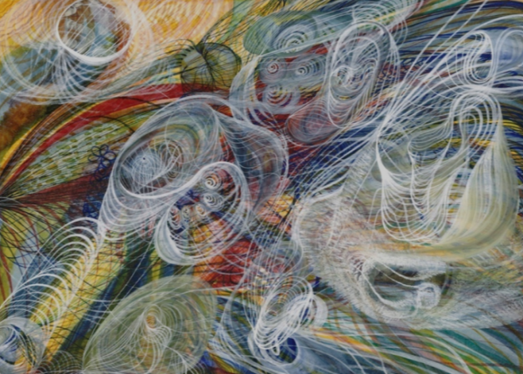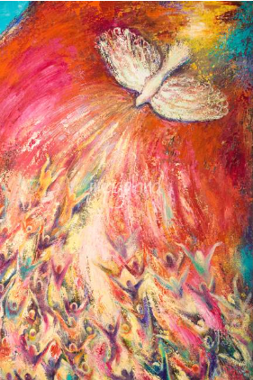

Year 5&6
Prayer | Liturgy | Mass | Hymns | Vocabulary
*Children creating and writing own prayers. | * Children to show more independence in leading prayer and worship.  *Children to give thoughtful reasons to why them have selected elements of planned liturgies. | *The Eucharist is a memorial of Christ’s sacrifice on the cross  Mass represents unity in the Church.  Children will be able to give reasons for each part of the Mass. | *Because the Lord is my Shepherd  *Go tell it on the mountain  *Make me Holy  *Help is on the way  *We will go  *Jesus, Remember me  *Love each other  *O Praise the name  *Maranatha | Gifts  Peacemaker  Unconditional love  Prodigal  Parable  Vocation  Marriage  Ordination  Vows  Service  Waiting  Promised one  Prophet  Emmanuel  Angelus  Mission  Cathedral  Diocese  Unity  Gentile  Memorial sacrifice  Passover  Consecration  Adoration  Genuflect  Acclamation  Maundy Thursday  Stations of the cross  Gethsemane  Crucifixion  Easter Vigil  Paschal candle  Transformation  Fruits of the Spirit  Martyrs  Sacrament of the sick  Social justice  Common good  Catholic Social Teaching
Images
